**WELCOME TO LITCHDON MEDICAL CENTRE –** FOR ADULTS

*Please complete this New Patient Questionnaire for our records*

# Please use a separate form for each family member

|  |  |  |  |  |  |  |  |  |
| --- | --- | --- | --- | --- | --- | --- | --- | --- |
| Title: | First Names: | | Surname: | | | | Any previous surname: | Marital Status: |
| Home Address: | | | | Home Number: | | | | |
| …………………………………………………………………………………… | | | | Mobile Number: | | | | |
| …………………………………………………………………………………… | | | |  | | | | |
|  | | | | |
|  | | | | Work Number: | | | | |
| …………………………………………………………………………………… | | | |  | | | | |
| ………………………………………………………………………………….. | | | | Email Address: | | | | |
| Postcode: …………………………………………………………………. | | | | Please sign: | | | | |
| DOB: | | NHS number: | | | | Gender: | | |
| (Optional – please circle)  Pronoun: He/Him or She/Her | | |
| Occupation | | | | | Education | | | |
| Height | | | | | Weight | | | |
| **Text messages**  **Please tick the box confirming that you are happy for the surgery to send you text message reminders regarding appointments, services, and feedback on the service.** | | | | | | | | |
| **Emails**  **Please tick the box confirming that you are happy for the surgery to send you emails regarding appointments, services, and feedback on the service.** | | | | | | | | |

**Next of kin**

|  |  |
| --- | --- |
| Name:  Address:  Postcode:  Telephone Number: | Relationship to patient: (e.g., Mother, Father, Guardian)  Sign: |

|  |  |  |  |  |  |  |  |  |  |  |  |  |  |  |  |  |  |  |  |
| --- | --- | --- | --- | --- | --- | --- | --- | --- | --- | --- | --- | --- | --- | --- | --- | --- | --- | --- | --- |
| **Your**  **Religion:** | **C of E** | | **Catholic** | | **Other Christian (state)** | | | | | | | **Buddhist** | | | **Hindu** | | | **Muslim** | |
| **Sikh** | | **Jewish** | | **Jehovah’s Witness** | | | | | | | **No religion** | | | **Other religion (state)** | | | | |
|  | | | | | | | | | | | | | | | | | | | |
| **Your Ethnic Origin:**  **(select one)** | | | **White (UK)** | | | | | | | **White (Irish)** | | | | | | **White (Other)** | | | |
| **Caribbean** | | | **African** | | | | | | | **Asian** | | | | | | **Other Mixed**  **Background** | | | |
| **Indian /**  **Brit Indian** | | | **Pakistani /**  **Brit Pakistani** | | | | | | | **Bangladeshi / Brit Bangladeshi** | | | | | | **Other Asian**  **Background** | | | |
| **Other Black**  **Background** | | | **Chinese** | | | | | | | **Other** | | | | | | **Ethnic Category**  **not stated** | | | |
|  | | | | | | | | | | | | | | | | | | | |
| **Your main or 1st language Spoken / Understood:**  **(select one)** | | | **English** | | **Hindi** | | | | **Gujurati** | | | **Urdu** | | | **Bengali /Sytheti** | | | **Punjabi** | |
| **Polish** | **Ukrainian** | | **French** | | **German** | | | | **Spanish** | | | **BSL** | | | **Other:**  **(Please Specify)** | | | | |
| **Will you need help in translation during contact with us? Y / N** | | | | | | | | | | | | | | | | | | | |
| **Smoking and Exercise:** | | | | | | | | | | | | | | | | | | | |
| **Are you currently a smoker?** | | | **Yes** | | **No** | | | | **Have you ever been a smoker?** | | | | | | **Yes** | | | **No** | |
| ***If you are a smoker, we advise you to stop, as there are many health benefits from giving up.*** | | | | | | | | | | | | | | | | | | | |
| **How often do you exercise?** | | | | **No. times per week** | | | | | | | **Type(s) of exercise:** | |  | | | | | | |
|  | | | | | | | | | | | | | | | | | | | |
| **Your Medical Background:** | | | | | | | | | | | | | | | | | | | |
| **What health problems do you have or have had in the past and when?** | |  | | | | | | | | | | | | | | | | | |
| **What operations have you had and when?** | |  | | | | | | | | | | | | | | | | | |
| **Do you have any medical problems at present?** | |  | | | | | | | | | | | | | | | | | |
| **If on Warfarin, what type of regular blood test do you have? (Please tick one)** | | INR*/finger prick blood test 🞎 ***OR*** Blood taken from a vein in your arm 🞎 | | | | | | | | | | | | | | | | | |
| **Repeat Medication** | | **If you have medication on repeat prescriptions, please provide us with a printed copy of your repeat medication, from your current surgery, to enable us to safely register you.**  Please ensure you have 3-4 weeks’ worth of medication from your current practice and please note you must then request your 1st repeat prescription from Litchdon to enable your records to be updated.  (This will not happen automatically) | | | | | | | | | | | | | | | | | |
| **If you live further than 1 mile from a pharmacy, we can dispense your medication from the Practice.** | | Tick to be a dispensing patient. | | | | | | | | | | | | | | | | | |
| **Alternatively, you can nominate a local chemist for your prescriptions to be sent to.** | | Name and location of chemist: | | | | | | | | | | | | | | | | | |
| **Are you able to administer your own medicines?** | | **Yes** | | | **No – please detail specific issues (e.g., swallowing, opening containers)** | | | | | | | | | | | | | | |
| **Are there any**  **serious diseases that affect your parents, brothers, or sisters**  **(tick all that apply)** | | **Diabetes** | | | | **Heart Attack** | | | | | **Heart attack under 60 years of age** | | | | | | **Bowel Cancer** | | |
| **Breast Cancer** | | | | | | | | | **High Blood Pressure** | | | | | | **Asthma** | | **Stroke** |
| **Thyroid Disorder** | | | | | | | | | **Any other important family illness?** | | | | | | | | |
|  | | | | | | | | | | | | | | | | | | | |
| **What immunisations have you had? (Tick all that apply)** | **Diphtheria** | | **Measles** | | | | **German Measles** | | | | | | | **Tetanus** | | | **Polio** | | **MMR** |
| **Whooping Cough** | | | | | | **Pre-school booster** | | | | | | | **Triple vaccine (Diphtheria,**  **Tetanus & Pertussis) –**  **3 doses** | | | | | |
| **Specific Needs:**  **Please detail below any specific needs you have so the Practice can ensure they are identified and accommodated by taking the appropriate action:** | | | | | | | | | | | | | | | | | | | |
| **Please state any sensory impairment you have.**  **(e.g., speech, hearing, sight):** | | | |  | | | | | | | | | | | | | | | |
| **Are you an ‘assistance dog’ user?** | | | |  | | | | | | | | | | | | | | | |
| **Please state any physical disabilities you have:** | | | |  | | | | | | | | | | | | | | | |
| **Please state any mental disabilities you have:** | | | |  | | | | | | | | | | | | | | | |
| **Please state any requirements you have to be able to access the Practice premises** | | | |  | | | | | | | | | | | | | | | |
| **Please state any religious or cultural needs:** | | | |  | | | | | | | | | | | | | | | |
| **Do you require the help of a translator / interpreter?** | | | |  | | | | | | | | | | | | | | | |
| **Please state any specific nutritional requirements you have:** | | | |  | | | | | | | | | | | | | | | |
| **Please state any allergies and sensitivities you have:** | | | |  | | | | | | | | | | | | | | | |
| **Please state any phobias you have:** | | | |  | | | | | | | | | | | | | | | |
| **Do you receive support from a professional agency – probation,**  **dv services, MH teams?** | | | |  | | | | | | | | | | | | | | | |
| **Have you accessed services in the last 3 months?** | | | |  | | | | | | | | | | | | | | | |
| **If you require support to access agency’s specified if you have relocated to this area, please let us know** | | | |  | | | | | | | | | | | | | | | |
| **Are you a carer?** | | | | **Yes / No** | | | | ***If “Yes”, please provide the name and relationship of the person(s) you care for:*** | | | | | | | | | | | |
| **Do you have a carer?** | | | | **Yes / No** | | | | ***If “Yes”, please provide your carer’s contact details:   Sign here if you wish for us to disclose information about your health to your carer:*** | | | | | | | | | | | |
| **Do you have a “Living Will”?**  **(a statement explaining what medical treatment you would not want in the future)** | | | | **Yes / No** | | | | ***If “Yes” Please bring a written copy of it into the surgery so we can add it to your medical records*** | | | | | | | | | | | |
| **Have you nominated someone to speak on your behalf?**  **(e.g. a person who has Power of Attorney)** | | | | **Yes / No** | | | | ***If “Yes”, please state their name, relationship, address & phone number:    And please bring a written copy of it into the surgery so we can add it to your medical records.*** | | | | | | | | | | | |

|  |  |  |  |  |  |
| --- | --- | --- | --- | --- | --- |
| **Have you ever served in the**  **armed forces?** | | **Yes / No** |  | | |
|  | | | | | |
|  | | | | | |
| **If you would like online access for booking appts, ordering medication and viewing your medical record please download the NHS APP which is an easy way to access your records.** [**https://www.nhs.uk/nhs-app/**](https://www.nhs.uk/nhs-app/) **An alternative to using the APP if you do not have a smartphone or a tablet is to request SystmOne online access via our Healthcare Administration Team in the practice. We will require photo ID and we then provide you with a username & password.  We also provide an eConsult service where you can receive help, advice, and treatment for your health problems online.**  **Use the “Contact us online” button on our practice webpage:** [**www.litchdonmedicalcentre.co.uk**](http://www.litchdonmedicalcentre.co.uk) | | | | | |
| **Patient Participation Group**  **The Practice is committed to improving the services we provide to our patients.**  **To do this, it is vital that we hear from people about their experiences, views, and ideas for making services better. By expressing your interest, you will be helping us to plan ways of involving patients that suit you. It also means we can keep you informed of opportunities to give your views and update you with developments within the Practice. If you are interested in getting involved, please provide your name, email address, and contact telephone number and we will pass these details to the group coordinator.**  **Name:**  **Email address:**  **Telephone number:** | | | | | |
|  | | | | | |
| **Patient**  **signature:** |  | | | **Signature on**  **behalf of patient:** |  |
| **Name of person signing on behalf of patient.** |  |

**Please complete this Alcohol Intake Screening questionnaire**

**Name: Age: Date completed:**



***Please follow the instructions and complete the following questionnaire:***

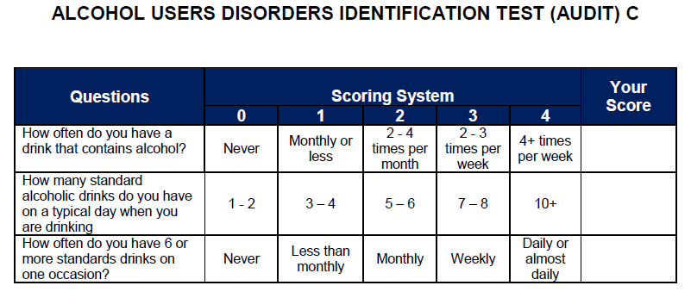

***If your score is 5 or more, please complete the additional questionnaire on the next page.***

***Additional questionnaire:***

***Name:***

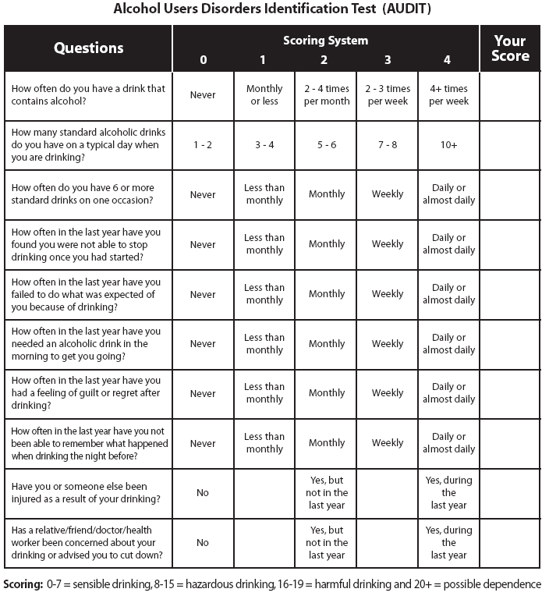

***If your score on this sheet indicates hazardous or harmful drinking, we would recommend you reduce your alcohol intake. If you would like help, please make an appointment with the doctor or nurse.***

**SHARING YOUR NHS PATIENT DATA**

With the development of information technology, the NHS will increasingly be sharing key information from your GP medical notes with Out of Hours GP Services, Hospital A&E Units, Community Hospitals, and Community Nurses - all of whom may at various times in your life look after you. Sharing information can improve both the quality and safety of care you receive and, in some cases, can be vital in making life-saving decisions about your treatment.

Information sharing in the NHS is subject to rigorous regulation and governance to ensure your full identifiable and personal medical data is kept confidential and only ever seen by carefully vetted doctors, nurses and administrative staff responsible for overseeing your care.

**We will still require patient consent to allow the data to be shared** (unless there are circumstances where a patient does not have capacity to consent, and clinicians will act in the patient’s best interests).

# Summary Care Record (aka SCR)

If you are registered with a GP practice in England your SCR is created automatically, unless you have opted out.

Summary Care Records (SCR) are an electronic record of important patient information, created from GP medical records. They can be seen and used by authorised staff in other areas of the health and care system who are involved in your care (for example Hospitals, Out of Hours services and Ambulance paramedics).

Access to SCR information means that care in other settings is safer, reducing the risk of prescribing errors. It also helps avoid delays to urgent care.

At a minimum, the SCR holds important information about your

* current medication
* allergies and details of any previous bad reactions to medicines
* your name, address, date of birth and NHS number

**You can, however**, also choose to include **additional information** in the SCR, such as details of long-term conditions, significant medical history, or specific communications needs. This type of Summary Care Record is known as the **Additional Summary Care Record**. (this is recommended)

**LOCAL SHARED CARE RECORD (Requires patient consent to opt in)**

This is a Devon wide service initiative and includes: - Out of hours health services, hospital wards and A&E within Devon, Community Health services-such as District Nurses, Podiatrists, Occupational Therapists and SWAST (South West Ambulance Service Trust). It includes data such as recent diagnosis, test results, allergies, medications, current or past (and significant) illnesses, encounters and referrals.

Access will only be granted to health care professionals on a need to know basis with your consent.

**Additional Summary Care Record (requires patient consent to opt in)**

Benefits of using additional information in Summary Care Record

**If you consent** to the inclusion of **additional information** in your SCR, this will mean that more information will be available to health and care staff viewing the SCR. It will then be automatically updated when your GP record is updated. This is an effective way to:

* improve the flow of information across the health and care system
* increase safety and efficiency
* improve care
* respond to particular challenges such as winter pressures

It's particularly beneficial for patients who:

* have complex or long term conditions.
* suffer from frailty
* are eligible for flu vaccinations
* have dementia or learning disabilities
* have physical, sensory, or other disabilities, who can befit from recording any specific needs, for example communication needs, so that health and care staff can make reasonable adjustments
* are non-English speakers
* patients with carers whose details they want to share or who have appointed someone to have Health and Welfare Lasting Power of Attorney
* patients with specific care preferences

**ENHANCED DATA SHARING MODEL (aka EDSM) (Requires patient consent to opt in)**

The database and software used by our practice to store your GP health record is called “SystmOne” it is a very secure national system used by over 2000 GP practices and 4800 NHS organisations including GP out of hour’s services, children's services, community services and some hospitals. Most GP Practices in the North Devon locality use this same confidential clinical computer system. The system gives your GP the facility to share your record with other NHS health providers that use the same clinical computer system and are involved in your care for example the local Community Nurses who may look after you if you when you leave hospital or become terminally ill or housebound. Allowing your GP to share your record in the “SystmOne” database helps to deliver better and safer care for you. It is the policy of all local GP practices to automatically opt registered patients into “SystmOne” sharing unless they expressly decline. Those patients who choose to decline are able to determine if their data is “shared out” and/or “shared in”

Sharing **OUT** controls whether information recorded at our GP practice can be shared with other NHS health care providers.

Sharing **IN** determines whether or not our GP practice can view information in your record that has been entered by other NHS services who are providing care for you or who may provide care for you in the future (provided that you have consented to share out).

**RESEARCH AND PLANNING**

**Research and planning -** Information about your health and care helps the NHS to improve your individual care, speed up diagnosis, plan your local services and research new treatments.

In May 2018, the strict rules about how this data can and cannot be used were strengthened. The NHS is committed to keeping patient information safe and always being clear about how it is used. **You can choose whether your confidential patient information is used for research and planning.** To find out more visit**:** [**www.nhs.uk/your-nhs-data-matters**](http://www.nhs.uk/your-nhs-data-matters) and Your Data Matters campaign at ico.org.uk

**SHARING YOUR NHS PATIENT DATA**

Please complete and tick the boxes below to detail your personal decisions regarding the aspects of NHS patient data sharing.

It is very important you sign this form to say that you understand and accept the risks to your personal health care, if you do decide to opt out of SCR or EDSM.

Hand the completed form in to your GP surgery: they will scan this form into your NHS GP medical records and enter the appropriate computer codes.

When we refer you to another health professional for care, we need to give them your medical history, so they are aware of your health & any medication you are taking.

If for any reason you do not want us to share your medical history, please inform the doctor at the time of referral.

|  |  |
| --- | --- |
| Patient full NAME |  |
| Patient DATE OF BIRTH |  |

# SCR NHS SUMMARY CARE RECORD

Please tick **only one box**

**YES** Express consent for medication, allergies and adverse reactions only (XaXbY)

**YES** Express consent for medication, allergies and adverse reactions and additional information (**recommended**) (XaXbZ)

**NO** Express dissent – patient does not want a Summary Care Record and fully understands the risks involved in this decision.

(XaXj6)

# EDSM – ENHANCED DATA SHARING MODEL “SystmOne”.

**Sharing Out** – Do you consent to the sharing of data recorded by your GP practice with other NHS organisations that care for you?

**YES** Share data with other NHS organisations (**recommended**)

**NO** Do Not share any data recorded by my GP practice; I full accept the risks associated with this decision.

**Sharing In** – Do you consent to your GP practice viewing data that is recorded at other NHS organisations and care services that may care for you?

Consent given (**recommended**)

Consent refused; I full accept the risks associated with this decision.

# Local Shared Care Record

**YES** I consent to a local Shared Care Record (XaKRv)

**NO** I dissent to a local shared care record (XaKRw)

|  |  |
| --- | --- |
| Patient/ parent/ guardian signature: | Date |

*If you have any queries or questions, please contact the surgery on* ***01271 323443***

*Or visit our website* [*www.litchdonmedicalcentre.co.uk*](http://www.litchdonmedicalcentre.co.uk) *to “Contact us Online”*

***For more information about the Practice and services we offer, please see our website: www.litchdonmedicalcentre.co.uk***

Staff checklist – for internal use only

(Please tick to ensure these sections have been completed by the patient.)

|  |  |
| --- | --- |
| Next of kin details – to include name of person, relationship to patient and a contact telephone number |  |
| NHS Number provided |  |
| Copy of repeat meds list attached |  |
| Nominated Chemist – is the patient eligible to be a dispensing patient? |  |
| Alcohol Questionnaire completed |  |
| Data Sharing completed & signed |  |
| New patient registration (GMS1) has been signed |  |

|  |  |
| --- | --- |
| All checks completed by HAT (initials) |  |